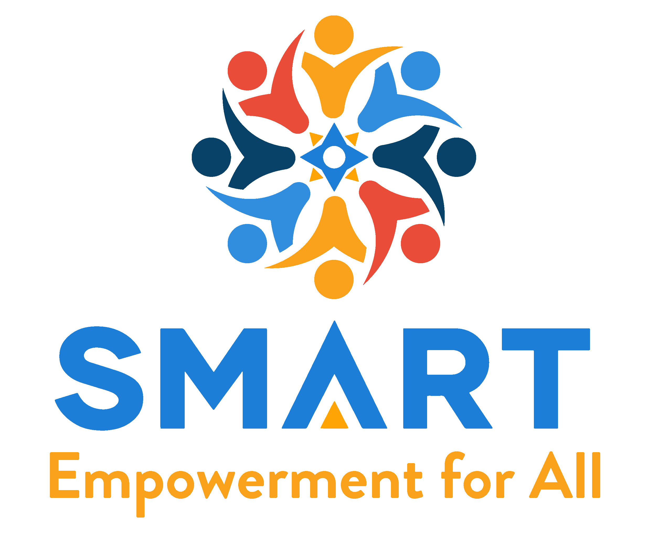

**Are you struggling with mental health and addiction?**

**JOIN the SMART Recovery Community!**

**Learn more about our about program.**

**Talk to someone about options available in addiction recovery.**

**Join a peer support community and give back.**

**Meetings are held by trained facilitators.**

**VOLUNTEERS NEEDED**

**Take our training and help us at a meeting.**

**For More Information, Contact Local Facilitator:**

**Christopher Huff**

**15-1338 Princess St. Kingston, ON**

**Office: (613) 817-1781**

**Cell: (343) 433-3424**

**Email:** [**info@smartrecoverykingstonontario.org**](mailto:info@smartrecoverykingstonontario.org)

**WEBSite: smartrecoverykingstonontario.org**

**Join online community in the Toronto region**

[**https://www.smartrecoverytoronto.com**](https://www.smartrecoverytoronto.com)

**Confidential Phone: 647-370-9620**